Operating Systems Lab

Assignment 3

Ashwin Waghmare
210010060

Part 1
The file schedule.c in minix/servers/sched is modified by adding the following code lines in the method schedule_process():

if(rmp→priority >= USERQ)
{
printf(“MINIX 210010060: PID %d swapped in\n”, _ENDPOINT_P(rmp→endpoint));
}
The if statement checks if the priority of the process is greater than equal to the USER_Q(which is defined in minix/include/minix/config.h) .
Also, a run.sh is provided which copies schedule.c to its location(minix/servers/sched/) and builds the src.
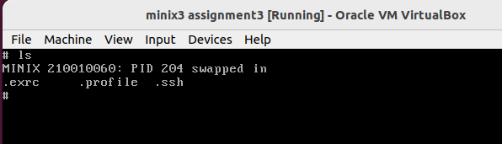

Part 2
Individual Benchmarks

1) arithoh.sh
- It is observed that no system time is used. The entire process is run in user mode as they are CPU intensive processes.
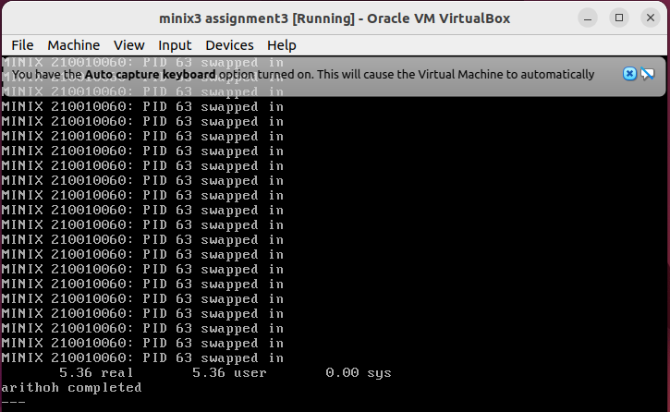
2) fstime.sh
- The real time is high as compared to user and system time because the process consists of several calls to time, date, sleep, etc.
- It is an IO bound process.
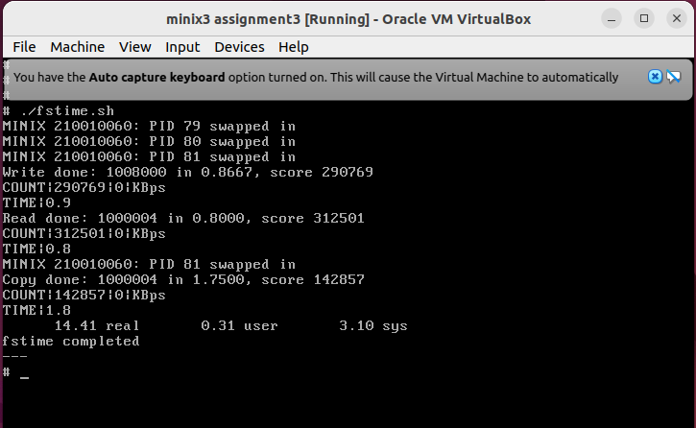

3) pipe.sh
- This benchmark mostly consists of system calls, hence mostly run in kernel mode.
- It is an IO bound process and involves repeated reads and writes to a pipe.
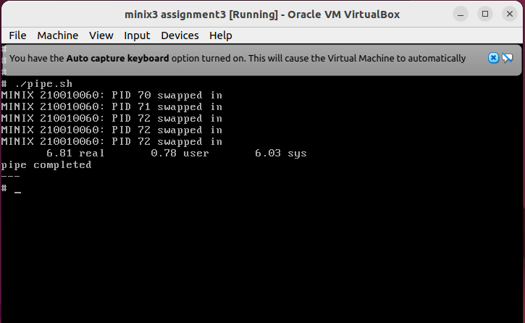
4) spawn.sh
- This benchmark mostly consists of system calls, hence mostly run in kernel mode.
- It goes through 100002 iterations where it forks, and immediately reaps the child it created.
- The memory-bandwidth and process creation mechanism is tested in this benchmark.
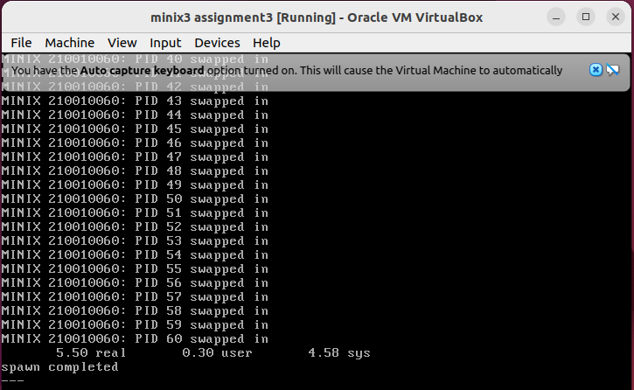

5) syscall.sh
- This benchmark mostly consists of system calls, hence mostly run in kernel mode.
- It does system calls and deals with file operators.
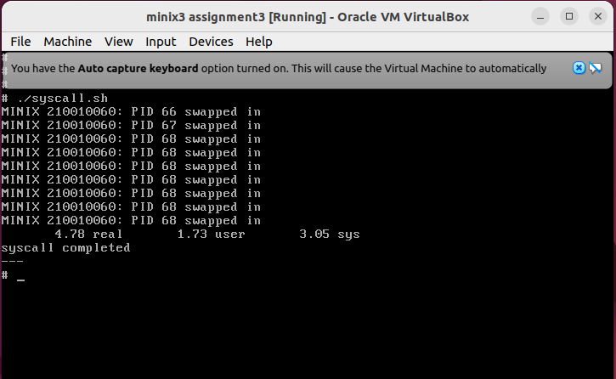
6) Workload mix of arithoh.sh and pipe.sh
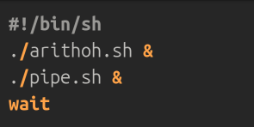

- It is observed that pipe completes its execution before arithoh as pipe consists of IO bound processes which have highest priority as compared to arithmetic operations.
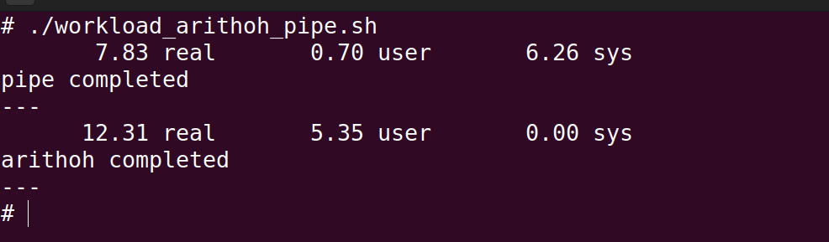

7) Workload mix of arithoh.sh and syscall.sh
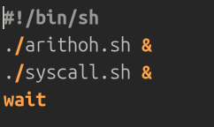

- It is observed that syscall completes its execution before arithoh as syscall consists of IO bound processes which have highest priority as compared to arithmetic operations.
